**SQL Case Study 4: Texture Tales**

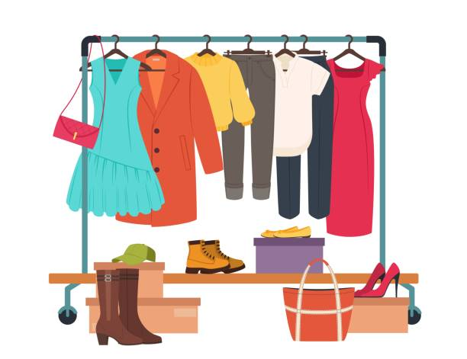

**INTRODUCTION:**

Texture Tales Clothing Company prides themselves on providing an optimized range of clothing and lifestyle wear for the modern adventurer!

The Managers of this trendy fashion company is asking you to assist the team’s merchandising teams analyze their sales performance and generate a basic financial report to share with the wider business.

**SCHEMA USED**

|  |  |
| --- | --- |
| product_details | |
| product_id | varchar |
| price | int |
| product_name | varchar |
| category_id | int |
| segment_id | int |
| style_id | int |
| category_name | varchar |
| segment_name | varchar |
| style_name | varchar |

|  |  |  |
| --- | --- | --- |
| sales | | |
| prod_id | varchar |
| qty | | int |
| price | | int |
| discount | | int |
| member | | varchar |
| txn_id | | varchar |
| start_txn_time | | varchar |

|  |  |
| --- | --- |
| Product_hierarchy | |
| id | int |
| product_id | int |
| price | int |
| start_date | date |
| end_date | date |

|  |  |
| --- | --- |
| product_prices | |
| id | int |
| product_id | varchar |
| price | int |

**CASE STUDY QUESTIONS**

1. What was the total quantity sold for all products?
2. What is the total generated revenue for all products before discounts?
3. What was the total discount amount for all products?
4. How many unique transactions were there?
5. What are the average unique products purchased in each transaction?
6. What is the average discount value per transaction?
7. What is the average revenue for member transactions and non-member transactions?
8. What are the top 3 products by total revenue before discount?
9. What are the total quantity, revenue and discount for each segment?
10. What is the top selling product for each segment?
11. What are the total quantity, revenue and discount for each category?
12. What is the top selling product for each category?